The Mathmatical Processes

**Headline News**

Yes, that’s right you heard it here, a new wave of teaching mathematics is coming, and it does not involve textbooks. Education is changing and adapting to fulfill students’ educational and developmental needs. The standard practice of mathematics is transitioning and is now becoming accessible, engaging, and meaningful for the learner. Math lessons will focus on student’s emotional development, communication skills, problem-solving techniques, and discovering connections to real-world problems. Traditional lessons require the learner to accommodate their learning process to the teaching style of the educator. Teachers are shifting towards the discovery of multiple areas of understanding and problem-solving. Textbooks fail to engage the learner, by only using one perspective and causes all students to accommodate their learning process. Students are able to collaborate with peers and practice problems with hands-on activities. Cross-curricular components are essential in developing a student’s understanding and helping them develop a bigger picture. Overall, your child’s math education is moving towards a brighter future that encourages communication, emotional regulation, and connections to real-world applications. Educators that use these big ideas will prepare the next generation of learners to create meaningful connections with the material, and allow them various activities for them to attain a well-rounded education.

|  |  |  |  |
| --- | --- | --- | --- |
| Elementry Education | Molly Cunningham | University of Victoira | 30-Mar-21 |

|  |
| --- |
| **No More Textbooks?** |
| **How Mathematical Education is Changing** |

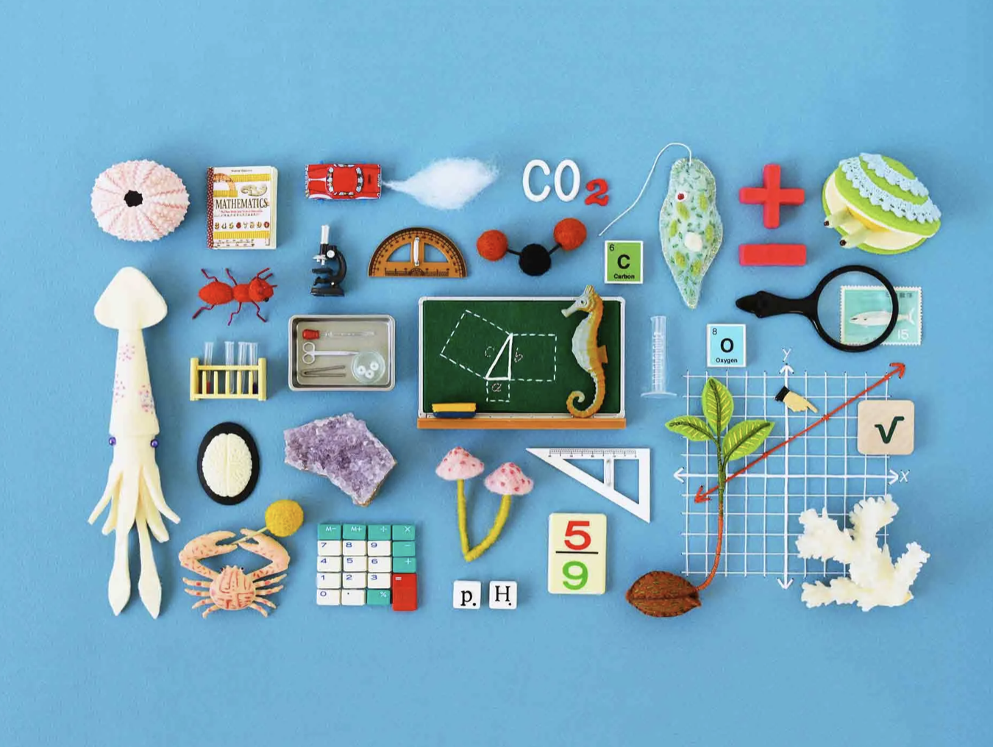

Photo by Hine Mizushima on Quanta Magazine

A shift in the Right Direction

The time has come for math lessons to shift and change for the betterment of student’s education. Textbooks and lectures fail to engage learners or leave them with a meaningful connection, therefore, some big ideas of the innovation of math education are coming. Communication and real-world connections are coming to classrooms and it is transforming what your idea of a typical math classroom looks like. There are activities without answers, and questions that have multiple answers, and multiple ways of problem-solving to encourage perspective and ease students’ learning process. This shift in the math class will increase motivation for students and allow learners to develop a meaningful connection with the material.

**Headline News**

**Real-World Connections and Problems**

Application and connection to the real-world with problems and activities, allow students to understand and recognize math in everyday life. Real-world problems and connections is a big idea of the mathematical process and aims at fostering students’ motivation. Teachers providing real-world problems, gives students a chance to relate their understanding to the world around them. Students learn how math stems beyond numbers and is a part of objects and our world. Students start to understand that math is not confined to a classroom, and they are math outside of the classroom and find it in art, music, architecture, nature, etc. Problem-solving activities that use reasoning and analyzing skills that are relevant to a real-world context, engages the student beyond school and opens up a world of possibility and understanding. Increasing students’ knowledge of how mathematical ideas interconnect and build on one another helps learners’ understanding develop to see the bigger picture. Students become motivated when they recognize math away from a classroom and can use their knowledge in and outside of school. Real-world problems form meaningful connections by relating their own experiences and journeys to the material. The more students are aware of connections with mathematical knowledge, the more motivation they obtain to recognize and apply math throughout their lives.

**Communication**

Learners’ understandings benefit when they can communicate their ideas, thoughts and knowledge, therefore, communication is big idea of the mathematical process. Peer collaboration and open classroom discussion helps students understand the math material in multiple ways from different perspectives. Communication and emotional development work together in providing a positive learning environment, and each benefit when practicing collaboration and peer integration. Lessons that embed communication increase students’ participations and foster meaningful connections. Communication helps students express and discuss math vocabulary and language with peers, thereby developing their understanding and fostering good retention skills. Teachers also need to model admirable communication skills and share how we learn more when we fail, than succeed. Positive communication in teachers accelerates students’ communicational skills throughout lessons. Independent communication skills strengthen student’s ability to organize their math knowledge, thus, developing learners’ reasoning, analysis, and solving skills. Listening skills enhance and students share multiple perspectives and understandings which show students multiple ways of problem-solving. Overall, giving students activities and problems that encourage communication of math knowledge leads to discovery of new understanding and allow learners to form meaningful connections, thereby, increasing their knowledge retention.

**New Discoveries**



Whats the Parking Activity?

The objective of this activity is to test students’ manipulation and imagination skills, to encourage learners to think outside the box. The prompt asks students to decipher what number should be under the car given, relative to the numbers. This question does not test difficult math knowledge, rather it tests students’ inventive and imaginative skills. By flipping the activity upside down, one will notice that the parking spots go in order, and the number under the car would be 87. This activity is a great way to have students use their problem-solving skills and communication to discover and absorb multiple areas of understanding.

**Parking Activity**

This activity was presented in our mathematical processes class and I instantly started working alone to try and solve the pattern using a logical approach. I used my understanding of multiplication, division, addition, and subtraction to try and isolate the pattern. When we went out into breakout rooms, someone from my group instantly had the answer. I was baffled and had no idea how they landed on an answer so quickly. They told me to turn my paper upside down and the answer would be very simple to solve. I chose this activity because it is intended for elementary students, yet I am in university and it tricked me. I was taught to use approach a math problem logically and critically, while using usually only one problem-solving strategy. My math classes only involved numbers, equations, and textbook question, although I enjoyed learning the material, the lessons failed to reach my highest learning potential. This activity led me to discover my peers problem-solving strategies, and how imagination is a part of the process. I learned that to teach math one needs to go beyond numbers and calculations, especially for early education. Furthermore, that communication is essential for expanding knowledge and gaining motivation. Personally, I realized that I approach math problems in one direction, and fail to use imagination or strategize outside the box thinking. As a prospective teacher I am continuously learning new ways to instruct students and expand their math investigation strategies and knowledge. In addition to this, opening students minds to multiple perspective through communication encourages students’ achievement, therefore delivering a well-rounded and brighter education. In my opinion, the most challenging part of this activity was my inability to use imagination over logic in my problem-solving strategies. Rather than take the time to visualize the problem, my educational upbringing directed a logical strategy, using numbers and equations to solving it efficiently. My education involved mad minuets and specific textbook question to solve answers as quickly as possible, stripping my math learning of imagination and perspective. These qualities are crucial to engage all students learning possibilities and prepare students for higher education. Although I received a high achievement in mathematics, my education lacked comprehensive and diverse lessons, thus, I was unable to visualize and use creativity in my problem-solving. To address this challenge, I am actively changing my problem-solving strategies, and I have started taking the time to look over and read problems thoroughly. I communicate with my peers to learn new perspectives and new problem-solving techniques. This is my way of strengthening my imagination, and taking a step back to look at the whole picture.

**New Discoveries**



Whats the UNICEF Investigation?

This Activity’s allows student to apply their math knowledge in a real-world context. The learning objective is for learners to achieve personal development and use problem-solving, through the students’ ability to choose items mathematically with regard to a budget. Anywhere education raised $1,417.84 at a fundraiser to provide survival gifts for children in another part of the world who have very little.Students’ engagement levels rise through the application of problem-solving that connect to real-world issues. I believe that this whole activity is possible, and would be a beneficial project as a school wide initiative.

**UNICEF Investigation**

Working on this investigation I discovered important values about myself that stem beyond mathematics. I chose this activity as a new discovery because it uses real-world context and showed me how far a small sum on money can help and influence another country. To prepare for this investigation I mentally put on other individuals’ shoes and thought about what survival gifts would be most important and why. I have been aware of how privileged it is to live in Canada; however, this assignment fulfilled my gratitude of basic human needs and made me thankful and my education and the opportunities I have. Furthermore, this assignment challenged my math skills using real-world connections and allowed me to see a bigger picture of how my math skills can be used to help and aid others. I discovered new values and significant comprehensions of myself, regarding my values of universal basic needs. Our assignment objectives were to use our problem-solving skills to plan a list of survival gifts to send, that was calculated mathematically as close as possible to the total donation’s funds received. The survival gifts included multiple items of food, water, sanitary needs, health vaccines, jackets, toys, children’s education, etc. In order to determine the list, I needed to decide what I believed was most important, between food and water, or health and education, and I realized I had no way of choosing because all the items were essential to my daily life. This was my extensive learning challenge as I could not determine what was most important. Therefore, I split up the survival gifts into categories—food, water, health, education, and fun—and started sorted gifts I chose evenly among each section. In addition to this I picked higher valued items that distributed to the most amount of people. This was very challenging and time consuming as I had to research what this developing country most important needs were, and what benefited their well-being. As the amount of money decreased, I then began problem solving and using my math knowledge to determine strategically what items to buy, in order to use the most amount of funds. In addressing my challenges, I believe that more research and real-world experiences, such as traveling, would increase my knowledge and help decipher what I believe to be most valuable. These challenges were positive to my learning development as I am continuing to discover perspective and understand my values and belief. Furthermore, this investigation allows me to acknowledge my privilege and opportunities. This investigation allowed me to connect meaningfully and become engaged through its real-world application and my ability to apply my math skills outside of the classroom.

**Conections**



Activity Layout

For this activity, educators are able to teach on Orange Shirt Day or another day revolving First Peoples Principles of Learning. This activity is a way to engage students throughout all subject material, while following “Phyliss Wedstad’s Orange Shirt” story, that teaches students all about the residential schools and the abuse Indigenous children faced, in a way that is appropriate for elementary students. Students are given math tasks that use math vocabulary and problem-solving strategies relating to the story. Some example questions are “would Phyllis get her next birthday at home, if she had to stay 300 sleeps at school” or “Phyllis and children like her were separated from their families for 300 sleeps, what does 300 look and feel like?”. Students are able to connect with the material through real-world application and communication skills. Overall, this activity is designed for teachers to embrace Orange Shirt Day and provide questions in mathematics for the children to relate and understand the First Peoples Principles of Learning.

**Orange Shirt Day Story Activity**

This Orange Shirt Day activity unites the teachings of the First Peoples Principles of learning with mathematical problem-solving. The lesson begins with “Phyllis Wedstad’s Orange Shirt Story” to expand students understanding of Indigenous values, traditions, and history, and then uses correlating mathematical worksheets. This lesson’s objective is to educate students on our Countries history and to create a culturally safe environment where all students feel comfortable to learn and grow. The cross-curricular component allows students to work together and foster big mathematical ideas, such as communication skills and connections to real-world problems. Learners are able to practice number concepts and explore mathematical ideas in concrete, pictorial and symbolic forms. Through their practice they develop their math understandings through play, inquiry, problem-solving, and communication. I chose this activity because it uses problems that involve real-world application, which encourages learners to connect meaningfully with the material while sharing Indigenous principles and history. Students are able to connect with Phyllis emotionally through the story and worksheets and develop empathy for her treatment, therefore understanding the trauma she went through. All in all, this activity encompasses preeminent learning possibilities with the First Peoples Principles of Learning and fulfilment of mathematical big ideas. As a prospective teacher I was unaware of the possibilities in connecting First people’s principles of Learning with elementary math education. This activity gave me an introduction to the numerous methods of connecting the two subjects and how achievable and accessible the relationship can be. This activity fosters good communication skills through group work and oral storytelling, and it also allows students to relate with the material through real-world problems. Furthermore, this activity connects to the First People’s Principles through oral story telling and practicing math tasks that are related to Indigenous principles and history. Students use their communication skills and emotional development to understand Phyllis’s emotions and feelings, all while practicing problems that relate to the story being shared. The lesson displays a connection to the First People’s Principles because it embeds learning through

**Connections**

all while practicing problems that relate to the story being shared. The lesson displays a connection to the First People’s Principles because it embeds learning through stories, and brings recognition towards Indigenous Peoples historic events. The design of this activity is for Orange Shirt Day, yet I believe that these stories should be read throughout the year to embrace Indigenous culture and educate students on their traditions and way of life. This activity is very useful as one can change and apply similar questions and activities to several different Indigenous related stories. It allows students to reflect on their experience and develop perspective through the lesson interconnection of multiple subject areas. This story explains what Residential Schools were and how the First People were treated, in a way children are able to understand. Educating the young on our historical monstrosities will help students learn and grow towards reconciliation and extending their values and traditions. As I continue my education, I will bring this activity with me to my future classroom and provide students with connections of the First Peoples Principles throughout all subject material. I was unaware of the ability to connect mathematics and the First Peoples Principles; however, I believe now that it is accessible and essential to provide students with a rich education and allow students to connect with the material in a meaningful way.

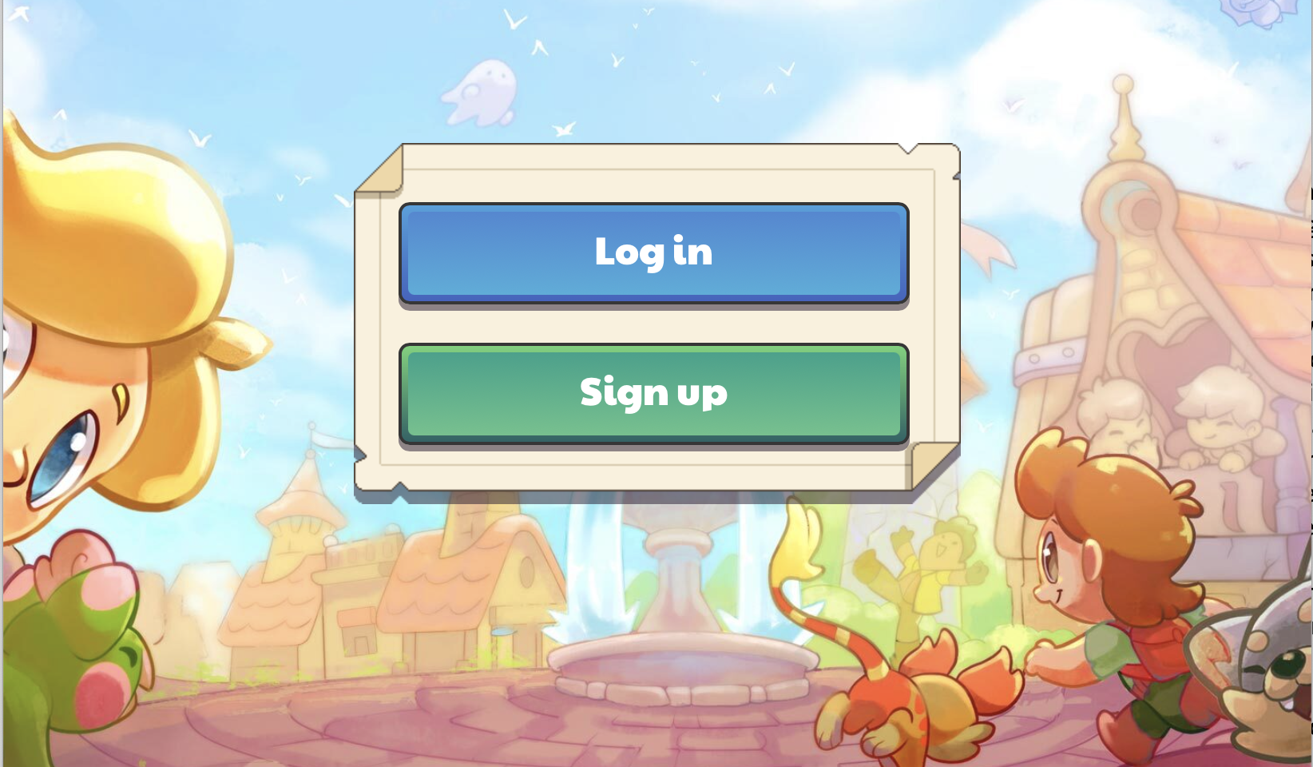

What is Prodigy?

This game is a fun and exciting activity that uses technology to engage student’s math knowledge. Teachers are able to program the classes usernames and passwords, to be accessible in the classroom and while the students are at home. Educators can modify the questions based on the academic level of the classroom, and what unit they are working on. You build an avatar and sidekick to take with you throughout different worlds while fixing houses and problem-solving to keep bad guys away. As an online platform it allows the students to become comfortable with technology, while practicing math skills and having fun.

**Additional Connection Activity**

Our Mathematical Process class was fortunate to test out the online math game [Prodigy](https://www.prodigygame.com/main-en/). This game was engaging for our university class and I believe that it would be an exciting and fun educational tool for an elementary classroom. This platform allows the teacher to design math problems as well as student accounts for classes to engage with online math learning. This website is beneficial for online learning with COVID-19 and allows learners to use technology while problem-solving engaging math questions. You can make your own avatar and challenge yourself to different worlds and levels the more problems you tackle. I believe that this platform is a great way to combine technology and math and increase motivation among students to practicing their knowledge. As a prospective teacher I would use this in my classroom as a cross-curricular connection to increase motivation and see how students are progressing with their math understandings.

**The Future**

**What are the big Ideas useful for?**

The mathematical big ideas, communication, and connection of real-world problems are essential for the innovation of math education. Using these big ideas will help teachers shift from traditional math lessons towards lessons that focus on the learners’ future and increase motivation with the material. Moving away from independent work and towards socialization and collaboration will help foster good communication skills where students can strengthen their understanding of the course material. Communication allows students to hear multiple perspectives and multiple problem-solving strategies to help aid their understanding. Students who communicate their math language and vocabulary skills retain knowledge better and it strengthens their understanding of the math curriculum. Communication skills not only help the learner, but also allows the teacher to hear the students and assess what material needs more explanation, or what students need extra help. Teachers can model communication skills and form a classroom that revolves around listening to others and communicating one’s understandings. Communication influences emotional development, by allowing students to openly discuss their thoughts, emotions, and feelings. Teachers can model positive emotional development by demonstrating how mistakes enrich one’s education and failure helps students learn. Communication is a big idea in mathematics because it brings learners together to collaborate and discuss and increases students’ ability to connect with the material in a meaningful way, thus, better preparing them for their future and higher academia.

Another mathematical big idea is creating problems that focus on real-world connections to increase student’s awareness of mathematics in everyday life. This style of questions and problem-solving process influences the classes’ motivation skills, through the students’ ability to relate to the material and discover math in new ways. Students can connect to the material and increase their understanding by looking at math in and out of the classroom. Furthermore, students can apply their knowledge towards other areas of education, thereby, learners can understand the bigger picture, of mathematics. This style of problem-solving teaches more than fundamental math skills, it also encourages exploration of their environment, and enhances their personal development skills. Overall, It shows students how to discover and apply mathematical practices in and outside of the classroom, increasing their understanding and better preparing them for higher education and academic success.

**The Future**

**What Questions do you Still Have About What You Consider to be the Big Ideas?**

As a prospective teacher, I see these big ideas—communication and connections to real-world problems—as a step towards higher and more valuable education. Communication is an essential skill for both the teacher and the students for knowledge and understanding. As I continue my Bachelor of Elementary Education, I ponder the questions of how to increase students’ communication skills independently, without the use of collaboration and discussion. I am interested in finding resources and activities that focus on independent communication with mathematics, to provide students will a well-rounded education that fosters independent and collaborative learning while strengthening students’ communication skills. Group collaboration is a great tool for gaining understanding, however, for higher education, I believe that the ability to utilize communication skills self-reliantly will better prepare learners for academic success. In addition to this, I believe that group discussion strengthens student’s communication skills, however, I wonder how would learners develop if they are shy or anxious. On my Wednesday visits for grade one, there were multiple students who were extremely anxious and timid to speak up or share their thoughts or answers. What are some ways as teachers we can be prepared for these learners and provide them with the same activities while acknowledging their needs?

As I stated above, I believe that connection to real-world problems is a delightful way to engage learners with school material and practice their mathematical understandings. It allows students to seek out mathematics in the real world and use their experiences in class to relate and connect meaningfully with the material. For my future of education, I ponder how relatable real-world problems would be with higher education in secondary and post-secondary schools. As important real-world connections are for motivating elementary students, I believe that high school students would really benefit if they were able to connect to the material and relate their experiences with the problems. The relatable real-world questions we have tackled in class have been fairly simplistic and aimed for lower grades, and I wonder how these questions would be styled for more complex problems and activities.

Overall, these big ideas I have shared are going to give mathematics a new outlook and allow all students to feel a connection with the material and gain a better understanding of the material. I ponder a few questions that may arise with these big ideas in a classroom and hope that all teachers adapt their math lessons to focus on the big mathematical ideas to enrich students' developmental and educational needs.